Welcome to the Fourth Annual Certāmen Carmentāle  Eleanor Roosevelt  The Country School  Dulaney  Easton  Montgomery Blair  Severn  Gilman  Calvert Hall  The Heights  Saint John’s  Rockbridge  Glenelg  Bullis  Saint Mary’s  and others?! |  |  | Alphabeta  Latīna  A B C  D E F  G H I  K L M  N O P  Q R S  T U X  Y Z  Did you know that the Emperor Claudius added three letters to the Roman alphabet? They didn’t last!  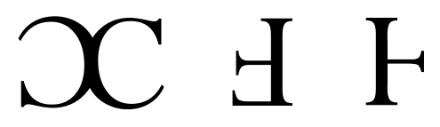 |  | Certāmen Carmentāle  - MDJCL with the National Latin Spelling Bee  Saturday, February 29, 2020  Loyola Blakefield  500 Chestnut Ave. Towson, MD 21204

Agenda  10:30 – 11:00 Registration and Activities  11:00 – 11:30 Session A  11:35 – 12:05 Session B  12:10-1:00 Lunch and Ludī!  1:05 – 1:35 Session C  1:45 – 3:00 Spelling Bee Heats and Final/Awards | Enjoy a morning of spelling-related activities including alphabet review, making abcedaria, alphabet games, practicing for a bee, and more. Students don’t need any previous experience with Latin spelling. After lunch we will have elimination rounds if necessary and host the fourth official Latin spelling bee in Maryland!  Nota Bene  The cost for each student to participate is $5.00. If you wish to purchase a pizza lunch, the cost is $8.00. Please pay at the registration desk. Schools can bring as many students as they wish. |  | Note to Teachers: Students compete individually and not in teams, so there is no minimum or maximum number of contestants from each school. Moderators are desired but not absolutely necessary, so parents can bring their children with or without the Latin teacher being present or older students may drive themselves.  Contact Us  Magistra Wise  202-441-7839  ewise@loyolablakefield.org  Please send me the number of students from your school that you expect to attend by Tuesday, February 25. E-mail to ewise@loyolablakefield.org.  The National Latin Spelling Bee is supported by a grant from the Classical Association of the Atlantic States.

